Periodic Table Puzzles
Rearrange the symbols for the elements and use the clues to figure out the words.

Example: Something to follow (Thorium + Protactinium)
Th + Pa = Path

You want to finish first (Cerium + Radium)
____ + ____ = ____________

Think of the moon (Argon + Nitrogen + Lutetium)
____ + ____ + ____ = ___________

Holiday home in the woods (Calcium + Indium + Boron)
____ + ____ + ____ = ___________
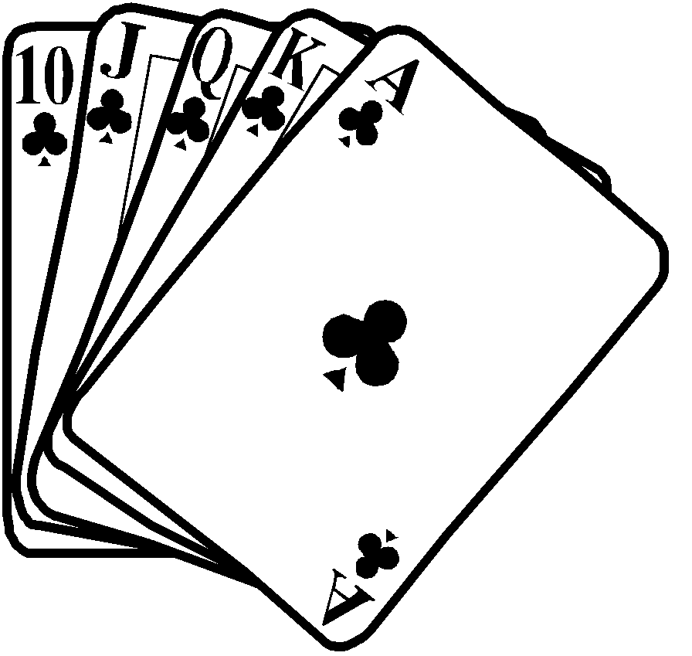
Card game (Erbium + Polonium + Potassium)
____ + ____ + ____ = ___________

A small angle (Uranium + Actinium + Tellurium)
____ + ____ + ____ = ___________

Sandy (Actinium + Beryllium + Hydrogen)
____ + ____ + ____ = ___________

Water vapour (Americium + Sulphur + Tellurium)
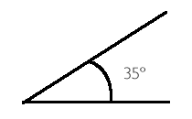
____ + ____ + ____ = ___________

Somewhere (Cerium + Lanthanum + Phosphorus)
____ + ____ + ____ = ___________

Unit of time (Cobalt + Neodymium + Selenium)
____ + ____ + ____ = ___________

Something you would like a lot of (Neon + Yttrium + Molybdenum)

____ + ____ + ____ = ___________

Beware of this snake (Oxygen + Carbon + Boron + Radium)
____ + ____ + ____ + ____ = ___________

A brother’s son (Tungsten + Phosphorus + Neon + Helium)
____ + ____ + ____ + ____ = ______________


Shirt and pants (Oxygen + Einsteinium + Chlorine + Thorium)
____ + ____ + ____ + ____ = ___________

Dracula’s bed (Indium + Carbon + Fluorine + Oxygen + Fluorine)
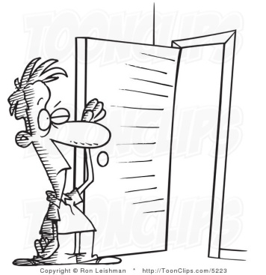
____ + ____ + ____ + ____ + ____ = _______________

Not anybody (Oxygen + Boron + Dysprosium + Nitrogen + Oxygen)
____ + ____ + ____ + ____ + ____ = _______________

Do this to a door (Nitrogen + Carbon + Potassium + Oxygen + Potassium)
____ + ____ + ____ + ____ + ____ = _______________

Try to find the end of this (Tungsten + Radium + Boron + Indium + Oxygen)
____ + ____ + ____ + ____ + ____ = _______________

Think Hawaii (Lanthanum + Iodine + Darmstadtium + Nitrogen + Sulphur)
____ + ____ + ____ + ____ + ____ = _______________

They can make you laugh (Oxygen + Chlorine + Tungsten + Sulphur + Nitrogen)
____ + ____ + ____ + ____ + ____ = _______________

A favourite food (Holmium + Cobalt + Tellurium + Carbon + Lanthanum)
____ + ____ + ____ + ____ + ____ = _______________

Large horned mammal (Erbium + Oxygen + Rhodium + Osmium + Carbon + Indium)
____ + ____ + ____ + ____ + ____ + ____ = ____________________

Now have a go at creating your own words and clues.

